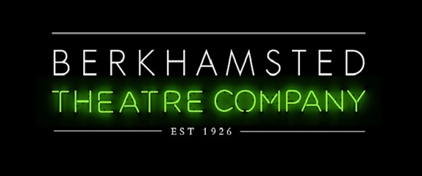
Earthquakes in London
AUDITION REGISTRATION
Sunday 9th February 2020
Felden Lodge HP3 0BB
All audition registrations to be received no later than 10am on Friday 7th February 2020
Show week of 22nd June
Print and complete this form then return to us at Earthquakes@berkhamstedtheatre.co.uk or submit to us
when attending one of the audition workshops on 3rd & 5th February
We will ask you to sign the completed form when you attend auditions.

Name: |  |  | Tel No:
Address: |  |  | Post code:
Email:
I wish to audition for the following roles: ( tick relevant boxes) – You will be notified of time slots prior to audition.
Grace ☐  Robert ☐  Steve ☐  Freya ☐  Jasmine ☐  Sarah ☐ |  |  |  |  | Tom ☐  Colin ☐  Simon / Roy / Daniel ☐  Carter ☐  Peter / Emily ☐  Mrs Andrews ☐  Ensemble ☐
If selected to take part, I undertake to regularly attend rehearsals with the exception of the following dates when I shall not be available due to holidays, business, other commitments or other shows:
Please read and confirm the following by ticking the boxes (click on the box)
On being offered/accepting a role in Earthquakes in London I understand and agree to pay the following:
☐Membership fee of BTC (£25 annual membership). Membership is due and payable on acceptance of any role (unless already paid within the last calendar year).
☐Show fee of £40

Signature |  |  |  | Date:
Please email completed form to: Earthquakes@berkhamstedtheatre.co.uk to reach us no later than 10am on 7th February 2020

